ICT Engineering

**SEP Y1 A16**

**Process Report**

Submitted to:

Birgitte von Fyren Balsløv

Steffen Vissing Andersen

Prepared by:

Cristian Cuibaru 253719

Denis Durovic 253794

Krystof Spiller 253812

Ovidiu Muresan 254119

Submitted: 16 December 2016

Contents

1. Group Policy 1

2. SWOT Analysis 2

2.1. Group SWOT Analysis 2

2.2. Individual SWOT Analysis 2

3. Considerations 3

4. Group roles 4

5. Meeting reports: 6

6. List of Tasks 6

7. Tasklog 7

# Group Policy

We agree to:

* Come to meetings.
* Make sure that when we miss meeting that we contact the others in our group and make other possible arrangements to assure that the work can be turned in on time.
* That we will work on group project collaboratively with each member having their fair share on the work.
* We are to treat each group member with respect and consideration during all tasks.
* Our behaviour should be conducive to progressing in our project and should not be disruptive to other group members.
* Show up at meetings at agreed place and time.
* Complete as much from the project as you can before group meetings.
* Assist others having trouble with the assignments and also not to hesitate to ask others for help.
* If there is not an agreement on a solution the group should discuss it and possibly vote for the result to be submitted.
* In case of Illness I am to notify all my group members and am responsible for catching up with work conducted in my absence.

This group contract is binding upon all who sign it and is subject to change with prior approval of all members of the group.

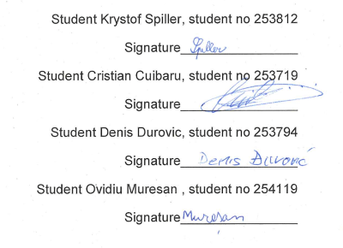

# SWOT Analysis

## Group SWOT Analysis

**Strengths**

Balanced team.

**Weaknesses**

Lack of programming and work experience.

**Opportunities**

Improving communication, teamwork and programming skills.

**Threats**

Lack of time.

## Individual SWOT Analysis

* **Krystof Spiller:**

**Strengths**

Thrive on challenge and pressure. Drive to overcome obstacles. Conscientious, perfectionist, searches out for errors. Analyzing all options and judge them constructively.

**Weaknesses**

Lacking ability to inspire and encourage others. Might be cold to others. Reluctant to delegate. Bad social skills.

**Opportunities**

Improving social, programming skills and team work.

**Threats**

Lack of time

* **Cristian Cuibaru:**

**Strengths**

Ideas from different angle, patient

**Weaknesses**

No Java experience

**Opportunities**

Improve my programming and teamwork, education skills.

**Threats**

Lack of time, dedication.

* **Denis Durovic:**

**Strengths**

Imaginative and creative, have a lot of ideas, dedicated when working and researching

**Weaknesses**

Forgetful, absentminded, unable to translate thoughts properly in words and present ideas

**Opportunities**

Improving social skills, programing skills, progress in our education

**Threats**

Lack of time, dedication.

* **Ovidiu Muresan:**

**Strengths**

Over checking everything just to be sure that we respect the schedule.

**Weaknesses**

Sometimes I don`t have patience

**Opportunities**

Improve my SDJ/RWD skills and maybe teamwork.

**Threats**

I`m too “honest” and lack of time.

# Considerations

## Considerations before writing the report

The Process report is aimed to a non-expert audience and therefore should be written in semi-formal style, without any technical expressions. The purpose of the report is to present the group members with few methods of self-assessment and personal reflections and considerations.

On the other hand, the Project report should be written in a formal style because it is aimed to an expert audience. That report contains technical information about how the project was done using analysis, design and implementation. It is assumed that the audience is familiar with the used terms.

## Personal considerations

Denis Durovic:

At first I was daunted by the task at hand and felt insecure about my role in the team. Eventually we all found parts in which we could contribute, be it in form of discussions with our fellow group mates or making plans on the upcoming project.

As days progressed I found my role as more of proof checker and documenting our work as it gradually developed. The dynamic of our team was pretty sound and we haven’t had many problems.

As the deadline came closer and closer we began fully being immersed into the project with daily meetings and our productivity skyrocketed. The overall challenges we were presented with made us all brainstorm quite a bit how to overcome and most of our solutions varied but that is what made this group great, many of us had different takes on the problems we faced and I believe with that variety we found solutions to many things some of us haven’t even considered.

All I can say is this project was an experience and I can safely say we have all learned quite a lot and we now have experience with working as a group.

Krystof Spiller:

I personally have an experience working on bigger projects and as part of high school graduation I had to make project even bigger in its extent than the one we were supposed to do here. However, I did that project on my own and worked four months on it. Therefore the group work on project of this extent was new for me and when we got the project, I knew it’s going to be hard, especially regarding the fact that we had less time for it, than I was used to, but I still thought it will be doable. It turned out, I was wrong.

Because I have the most experience with programming, I took the responsibility to design the structure of the program and coding the whole model and delegated the work on the GUI layout, project report and process report to respective team members. I was almost finished with my work week before the deadline, with only few things to tweak. I thought that week before the deadline, most of the process report, all that could have been done until then in the project report and the GUI layout, will be done and so only connecting the model with the GUI, finishing considerations in the process report and other relevant parts of the project report, which couldn’t have been done before, because they depended on the implementation and testing of the program, would remain.

Then the reality happened and process report was almost non-existent, project report wasn’t much better and the code for the GUI was automatically generated, looked like a spaghetti and had to be rewritten, although the layout was ready. The individual windows and parts of the GUI also weren’t interconnected. I originally thought I would spend the time working on the controller, but I had to work on the reports, javadoc and rewriting the GUI. In other words, I overestimated the abilities of all members as well as work ethic of some members.

Overall, I’m not satisfied with the result of the project and how the process was going, because I wasted a lot of time on things I originally wasn’t supposed to work on and therefore couldn’t finish the controller and make the program work as it’s supposed to. Working on this group project was however a valuable experience, especially in regards to the personal lack of group communication skills.

Ovidiu Muresan:

I have never had an experience like this before, the tasks we had in high school weren’t that important or either that complex, and were much easier compared to this one, even though we were working alone on the high school project. I think it is going to be really challenging for me since is the first time I’m going to work in a group, since a lot of jobs require cooperation I will just get along with it. Besides improving our programming skills by figuring things out on our own, we will also be better at communicating and solving problems together. Because you have to explain your ideas to others.

During the project, I learned that sometimes time passes faster than you would expect it to. I thought we planned our timetable well, but only in the last week of the project we actually realised that we have less than 5 days and a lot of things to finish. I know that a group needs to make a plan, and try to stick to it as much as possible. When a problem occurs it’s important for us to work together and talk about the issue we have and work to solve the actual problem instead of arguing. All in all, our project could be further improved, I’m glad that I had a chance to work with a well rounded group.

Cuibaru Cristian:

As the deadline was approaching I was getting more enthusiastic and stressed at the same time, since this is my first experience of working in a team on a school project. At first, I had no idea how we should separate the tasks in a way that everybody will consider it fair since each member had his own expectations about the project, different level of programming and the last, but not the least is that all of us are coming from different cultures.

Though, after working on a project for almost three weeks I consider that I gain enough experience to form my personal vision about group work, especially with people with different level of experience and attitude. Recalling from the very beginning, we decided that it will be better for everyone if we can work separately, instead of having meetings every week, which was a good idea, because in this way, we could have been more productive.

I think everyone tried to do his best and help other members in the process, but unfortunately, this did not work out as I expected, because some members just took the whole project on their shoulders. At some point I do not think this is fair in both ways, because the whole meaning of the semester project is to learn, how to handle the knowledge gained the whole semester and by another hand to learn how to work as a group. But, as the hand-in was getting closer everyone started feeling the pressure and this is when we began working as a group and started to separate our tasks as we thought will be the best for each member.

The last week was the period when a lot of work was done since we had a great communication and we tried to help each other the best we could. To sum it up, I could say that this was an important experience for me in my future career, because I will have to work forwards in the group.

# Group roles

* **Krystof Spiller:**

- Role: Shaper, Complete Finisher

- The most recent example I can give is from the LRL class, where I don’t have to think about the exercises but just do them. But the last LRL class we got an assignment, where we as a group had to think about some idea, what the robot can do and make exercise around it for others with our own solution to it. I didn’t get the initial idea but I was the one who started working on it and finished it.

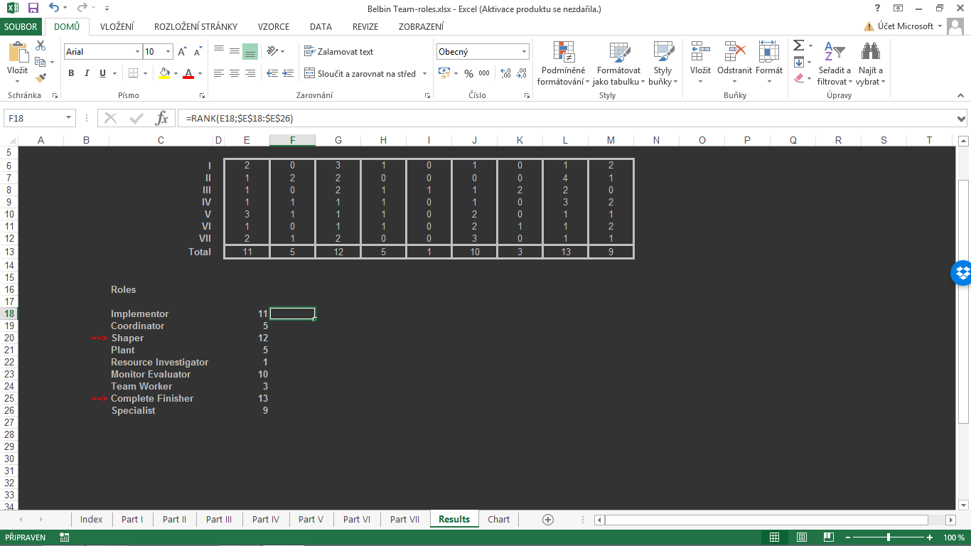- Prone to provocation, offends people’s feelings, inclined to worry unduly, reluctant to delegate, somewhat inflexible, slow to respond to new possibilities, can be overly critical and sceptical, lacks ability to inspire others.

* **Cristian Cuibaru:**

- Role: Implementer

- I try to listen to all suggested opinions in group project so we can split the tasks based on the knowledge of each individual member.

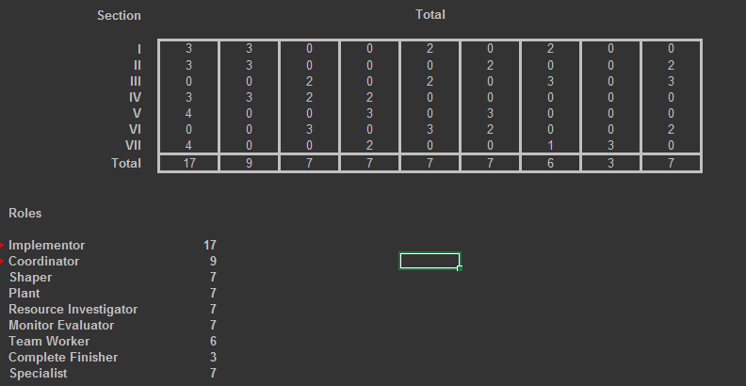- Sometimes for me it can be harsh to make decisions for the whole team so I try to listen to every member carefully.

* **Denis Durovic:**

- Role: Implementer, Plant and Specialist

- When we specialize in a subject I research as much as possible of the given subject accompanying it like with Advanced robotics

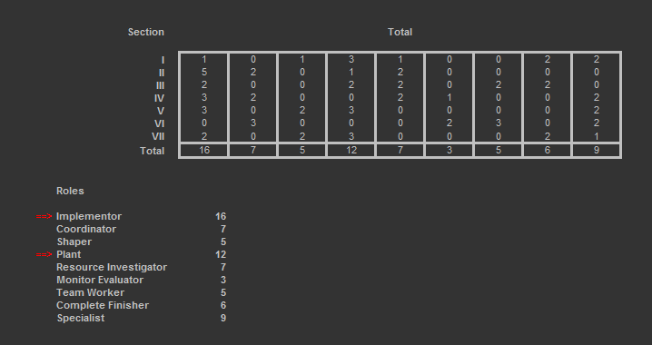- I like implementing good ideas into our work to enhance its quality like with all my presentations.

- Forgetful, slow moving and critical, indecisive, narrowly focusing on things.

* **Ovidiu Muresan:**

- Roles: Shaper, Teamworker

- When I start doing a project I like to have everything prepared from the first place. And I do not hesitate to ask people outside the group for information .

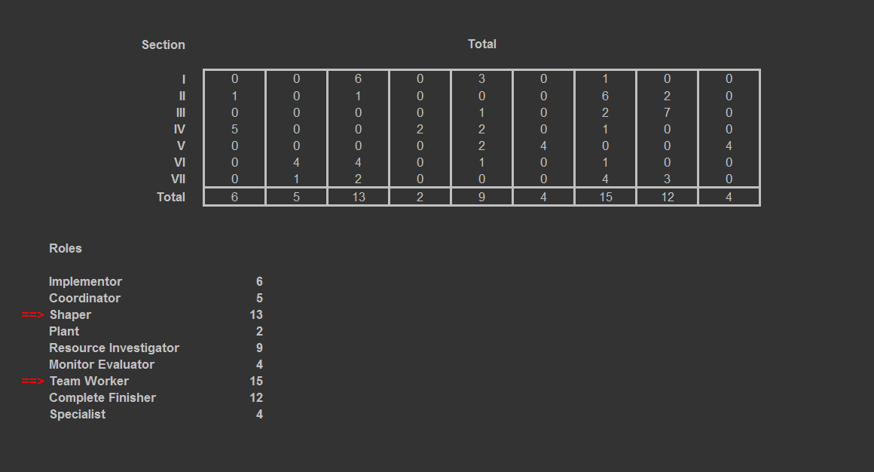- “Can be prone to provocation, and may sometimes offend people's feelings” about this, is not like that for me but if I argue with someone and I know I’m right I wont let it go .

# Meeting reports:

28th of November: The first official meeting with our supervisor Steffen Vissing Andersen

Discussion: clarification of various steps and simplification of code

1st of December: Second official meeting with our supervisor Steffen Vissing Andersen

9th of December: Third official meeting with our supervisor Steffen Vissing Andersen

Discussion: GUI operation and additional code work questions about the current state of our project

13th of December: Fourth official meeting with our supervisor Steffen Vissing Andersen

Discussion: questions about java Code, Javadoc and overall process and project documentation

# List of Tasks

**Krystof** – Made Use Case Diagram, Use Case Descriptions, Activity Diagrams and Class Diagram. Designed mockups of GUI. Coded the whole model. Structured the GUI and the controller and helped with the controller. Finalized Javadoc documentation and Sequence diagram.

**Cristian** – Contributed to Use Case Description, Activity Diagram and Class Diagram. Coded the GUI layout, handler and controller.

**Denis** – Contributed to Use Case Description, Activity Diagram and Class Diagram. Mainly worked on Process Report and Javadoc documentation

**Ovidiu** – Contributed to Use Case Description, Activity Diagram and Class Diagram. Mainly worked on Project Report, Javadoc documentation, and Sequence diagram

# Tasklog

|  |  |
| --- | --- |
| Date | Description |
| 1.11.2016 | Preliminary designs of the project and the discussion about how it will be done |
| 6.11.2016 | Visual mockup of how we want the project to look like and how the structure should look like |
| 10.11.2016 | Work on Use Case diagram started |
| 12.11.2016 | Work on Use Case descriptions started |
| 17.11.2016 | Creation of the Activity diagrams and Class diagram began |
| 20.11.2016 | Preparation of all materials for process and project reports  Including: Bloom forms, Felder reports, all diagrams and mockups, SWOT analysis of individual members, group policy |
| 29.11.2016 | Created the first GUI mockups and started coding the GUI layout 1 Started coding the model, Started documentation of Project & Process Reports |
| 2.12.2016 | Finished all the GUI mockups |
| 8.12.2016 | Majority of the model done. Started testing and fixing bugs. Javadoc comments implementation and proofing started. |
| 9.12.2016 | Finished coding the GUI layout. Started making the model dataset. |
| 11.12.2016 | Started working on the handler and controller. Rewriting parts of GUI layout to work with controller and handler. |
| 12.12.2016 | Thorough model test and fixing last bugs in the model. Implementing handler and controller. Process report preliminary overview and final changes |
| 13.12.2016 | More work on the GUI, Javadoc and reports. |
| 14.12.2016 | Making the sequence diagram. Functionality for the GUI. |
| 15.12.2016 | Finalizing javadoc documentation, project and process report. Implementing working with the model to the GUI. |

8. Bloom forms

Krystof Spiller

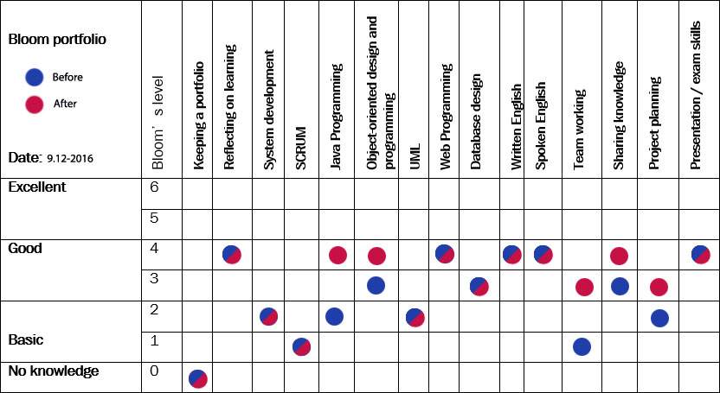

Cristian Cuibaru

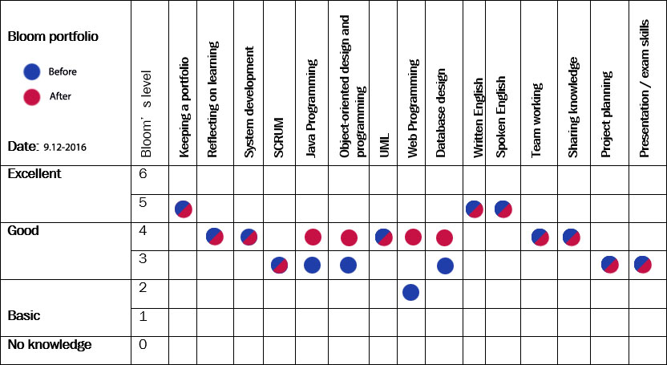

Denis Đurović

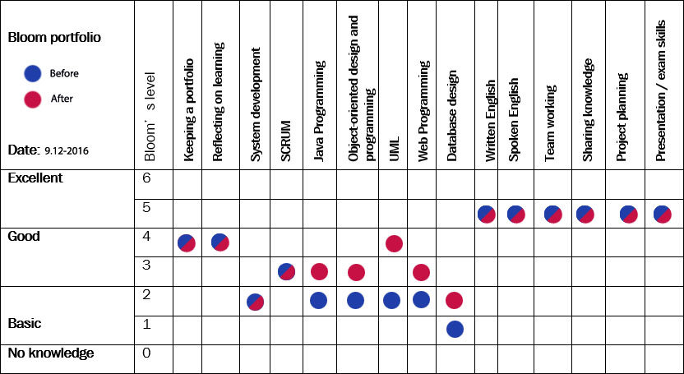

Ovidiu Muresan

